PERGAMON Carbon 38 (2000) 379–395
Preparation of activated carbon cloths from viscous rayon. Part
II: physical activation processes
a , a a b * ´ ´ F. Rodrýguez-Reinoso , A.C. Pastor , H. Marsh , M.A. Martýnez

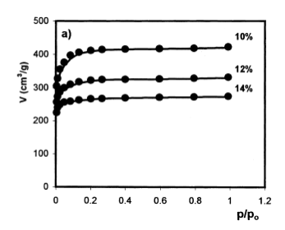

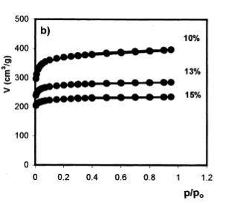

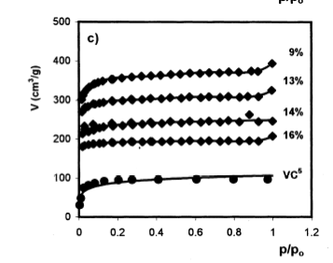

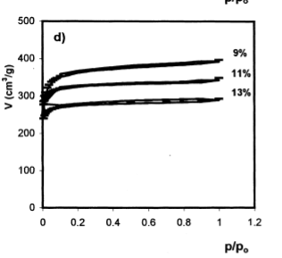

5 3 5 2 5 Fig. 9. Adsorption isotherms of nitrogen at 77 K: (a) series VC -C ; (b) series VC -C ; (c) series VC -C; (d) series V-C; (e) series V-C9; (f)
5 series VC -H; and (g) series V-H.

